1.1

Electrification

Electrification is the replacement of technologies that use fossil fuels (coal, oil and natural gas) with technologies that use electricity as an energy source

process. The goal is to convert everything to electric power, potentially reducing carbon dioxide (CO2) emissions in the transportation, buildings, and industrial sectors

(CO2) emissions in the transportation, building and industrial sectors, i.e., the decarbonization process mind

can be divided into transportation, building and industrial electrification-

can save resources, can benefit the grid and improve atmospheric quality

In addition to the environmental benefits, electric vehicles can benefit the grid by charging when power is available and demand is low and discharging into the grid when demand is high.

In addition to the environmental benefits, electric vehicles can also benefit the grid by charging when power is available and demand is low and discharging to the grid when demand is high. This capability is particularly useful for adapting to changes in variable renewable energy generation.

Informatization

Informationization is divided into electronic, process, automation and intelligence. These four are progressive relationships, and the former level is the basis for the latter level.

The foundation of the next level.

Electronicization is the classification and coding of information elements in a way that computers can recognize, store and process, which is the basis for the operation of informatization.

This is the basis of information technology operation.

Process is to sort out and define the sequence of each process of information processing, to clarify the input and output of each process, and to provide a basis for the realization of coordinated work.4

The basis for achieving coordinated work is provided.

Automation is to reduce manual intervention in the process of information processing, or to allow information systems to automatically complete information processing without manual intervention.4

The information system can complete information processing automatically.

Intelligence is the independence of information systems to provide personalized information processing. It is a more advanced form of automated processing

state. Information technology has always been considered a good means and way to implement the concept of legalism. A good information system is a

A good information system is a system with good and self-consistent rules, which runs and processes if it conforms to the rules, and does not process if it does not. -

Technical methods related mainly to the development of technical and technological tools and tools to support labor activities in the field of manufacturing and management ,

to improve efficiency and productivity.

Bay. Sociological approach, which considers informatization as an impact on all areas of human activity and reflected to all people in society -

one their knowledge, skills, moral, economic and cultural interests, personal development, etc.

Mediation: the process of improving the means of collecting, storing and disseminating information, mainly using electronic (digital) media, in order to speed up information

The process of improving the means of collecting, storing and disseminating information, mainly using electronic (digital) media, in order to speed up the transmission of information and to increase the possibilities of transmission methods.

Computerization: the process of improving the way information is searched and processed through the use of computer means, in which computers become the main means of communication for people, freeing them from the daily routine.

The process of computerization: the improvement of the way of searching and processing information through the use of computer means, in which computers become the main means of communication for people, freeing them from daily operations.

Intelligence: the process of development of human knowledge and the possibility of creating new information, which naturally increases the intellectual potential of society, including

The opportunity to use artificial intelligence. The role of intelligence in the contemporary information society for managing distributed socio-economic systems.

Digital space

Social Computing

Cloud computing Internet of Things Big Data is a characteristic product of informatization\*

Translated with www.DeepL.com/Translator (free version)

1.2

Nikolai. Tesla

1.3

Multi-phase high frequency alternator

Inside the generator there is a rotor driven by the engine (rotating magnetic field).

Outside the rotating magnetic field there is a stator winding with three sets of coils (three-phase windings), which are separated from each other by 120°.

When the rotor rotates, the rotating magnetic field causes the fixed armature windings to cut the magnetic induction lines (or to change the magnetic flux passing through the armature windings) and generate an electric potential.

The magnitude of the stator three-phase winding induced electromotive force is

em = Emsinωt =√2EΦsinωt

ev = Emsin(ωt -2/3π) =√2EΦsin(ωt -2/3π)

ew = Emsin(ωt+2/3π)=√2EΦsin(ωt+2/3π)

where Em - the maximum value of electric potential per phase; ω - the angular speed of the brush.

The RMS value of the stator electric potential per phase is Eφ=Em/(√2)=4.44KfNΦ

The amplitude of the AC electric potential is a function of the generator speed. Therefore, when the rotational speed changes, the waveform of the three-phase electric potential is an AC waveform with variable frequency and amplitude.

Connection of stator three-phase winding: The connection of stator three-phase winding has two types: star and triangle.

Relation to electrification

To promote the development of electrification by replacing DC power with AC power to a certain extent and improving the efficiency of energy output.

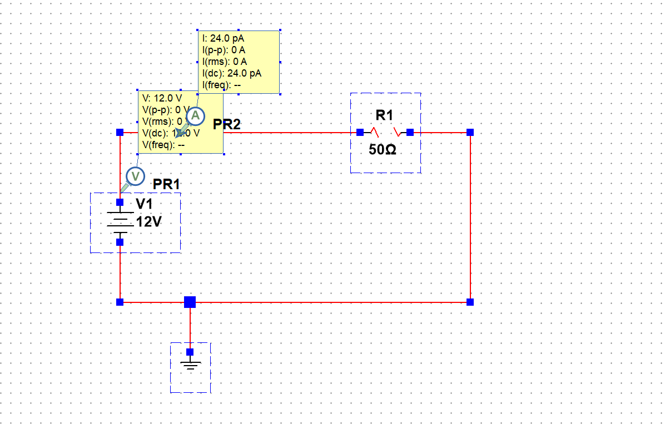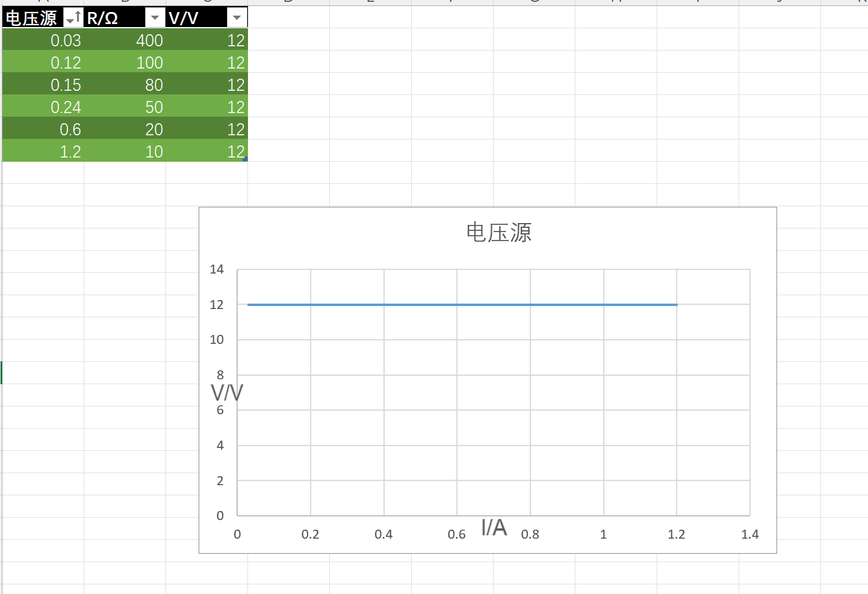

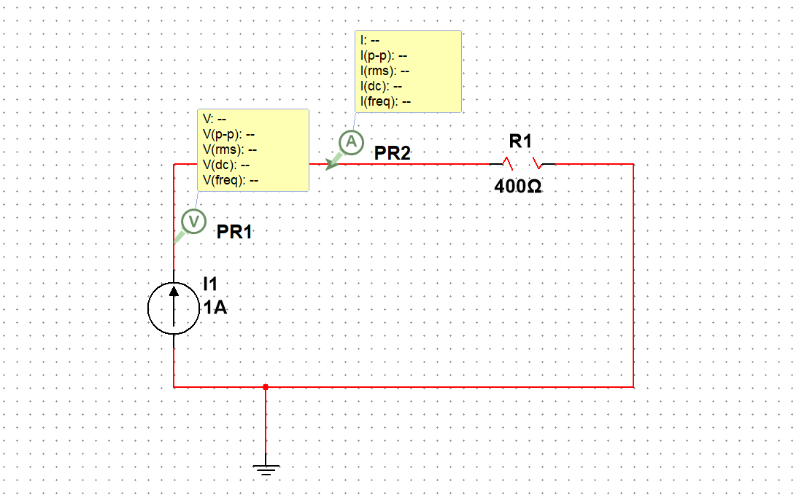

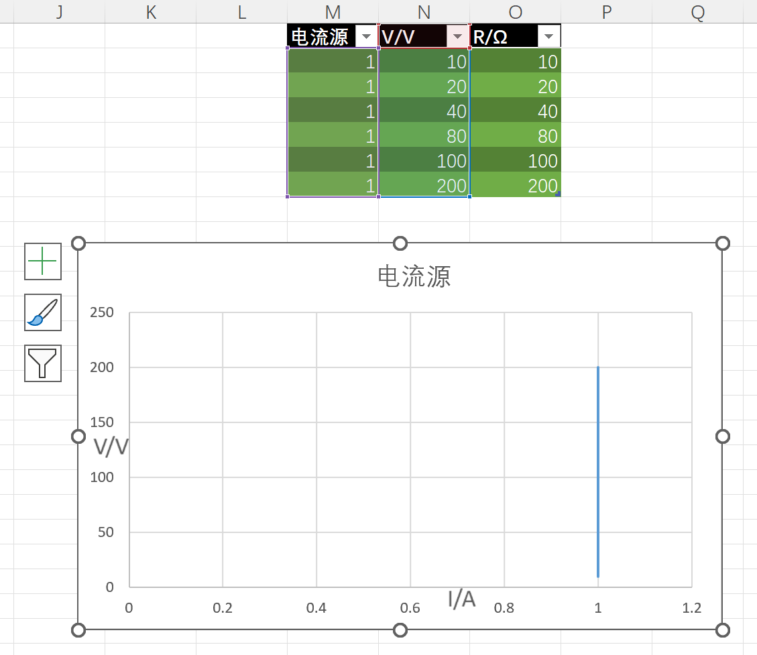

In 2.3, for i1, the current sources I1, I2, and voltage source V1 cancel each other out here, because the circuit is a linear circuit, so by the principle of superposition, i1 is the current generated by voltage source V2 here, which can be analyzed to get 3/（$\frac{1}{\frac{1}{3}+\frac{1}{5+10}}$）× $\frac{2}{2+5+10}$ =0.2A, direction to the right

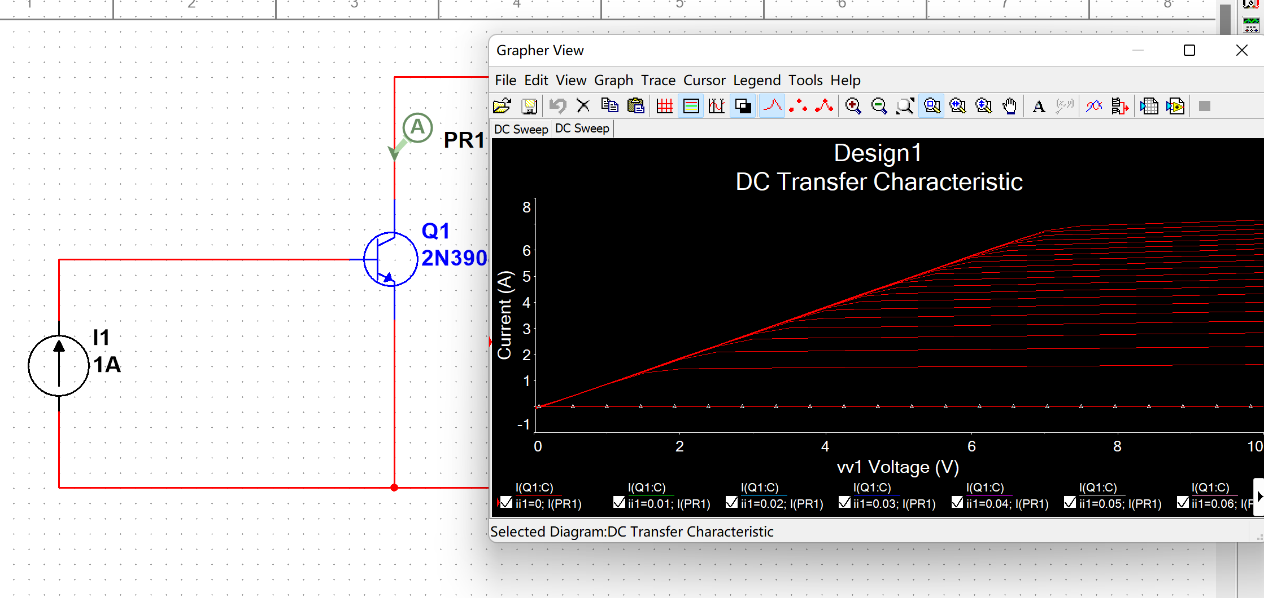

To turn on the NMOS, we need to charge it so that the gate voltage is higher than the source voltage.

To turn off the NMOS, we need to stop charging and increase the voltage in reverse so that the gate voltage is lower than the source voltage